LULU CANDICE YANG POORNI ZAW: Activities diagrams & screen design (hardcopy).

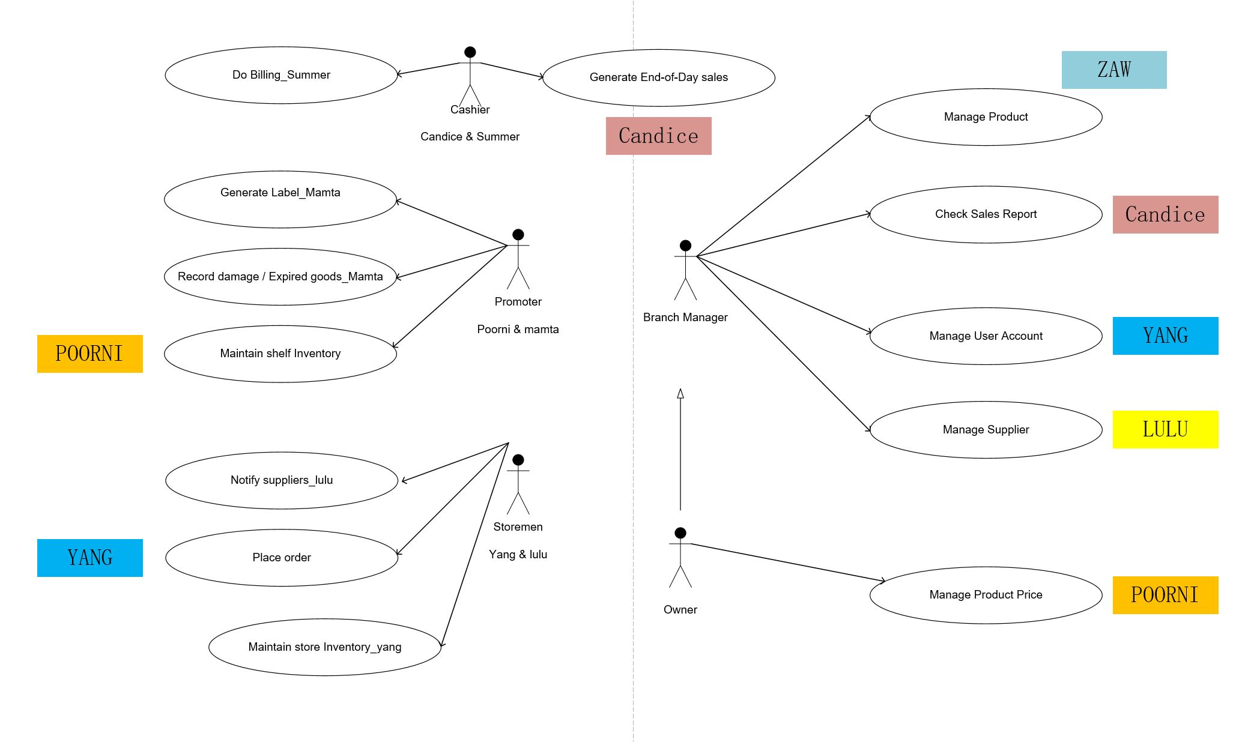

SUMMER MAMTA: FIVE TABLE (based on the final system use case).

EVERYONE: USE CASE Description (do assigned actor part only).

Sample:

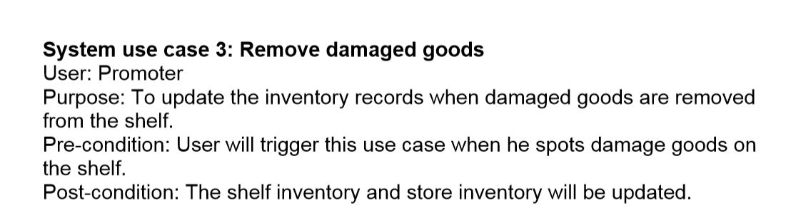

Check the final system use case in GFFfinal folder.